Charity Reg: 506755
Coronavirus Financial Government Schemes for Business
Owners, Employers and Employees

Last Updated: 25/03/2020

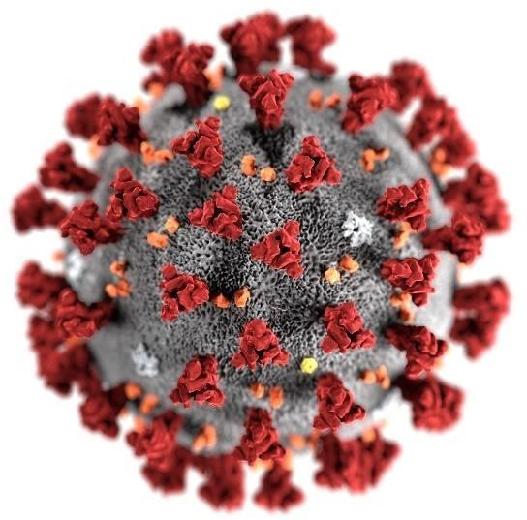

Idaara Maarif-e-Islam Hussainia Mosque and Community Centre
Regent Park Road, Small Heath, Birmingham, B10 0QP
Tel: 0121 773 6212
Email: info@hussainia.org.uk/admin@hussainia.org.uk Web: www.hussainia.org.uk
Page 2
Schemes & Checklist
Use the table below as a checklist to see which schemes are available to you.

Businesses
Scheme | Page No | Applicable to you?
Job Retention Scheme | 3
Statutory Sick Pay | 4
Deferring VAT | 4
Business Rates | 5
Cash Grant | 5
Interruption Loan Scheme | 6
Insurance | 6

Self Employment
Scheme | Page No | Applicable to you?
Universal Credit | 7
Deferring Income Tax | 8
Time to Pay Offer | 8

Individuals & Employees
Scheme | Page No | Applicable to you?
Job Retention Scheme | 9
Statutory Sick Pay | 10
Universal Credit & Working Tax Credit | 10
Mortgage Payments Holiday | 11
Other Loans | 11

Businesses Schemes

Job Retention Scheme
HMRC will support your business by paying 80% of each of your employees’ salary who would have been laid off during the crisis at the maximum of
£2,500.
Example?
You have one employee earning
£2,000 a month, so you will be able to claim 80% of this which is £1,600.
If you have a second employee earning £3,500 per month then 80% would be £2,800 however this would be capped at £2,500.

When will the scheme start?
The scheme is expected to start from the 1st April 2020 and last for 3 months. You can backdate claims from the 1st March 2020.

Is my business eligible for this scheme?
All UK businesses regardless of size will be eligible for this scheme.

Page 3

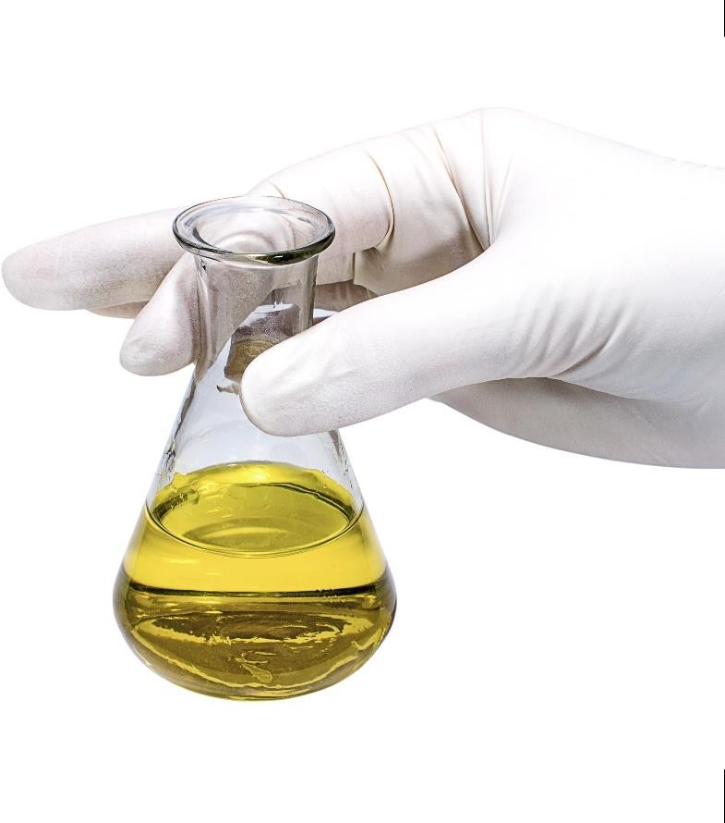

How do I apply for this scheme?
Firstly, you will need to designate any of your affected employees as furloughed workers and then you will need to notify your employee of this.
Secondly, you will need to make the claim through HMRC’s portal. We expect the reimbursement portal to be available from 1st April 2020.

Page 4

Statutory Sick Pay (SSP)
Statutory sick pay is currently £94.25 per week. If you have had employees on sick due to COVID-19 then you will be refunded the first 2 weeks of statutory sick pay paid to your employee.

Is my business eligible for this scheme?
The relief will be available to UK businesses with fewer than 250 employees as at 28th Feb 2020.
As an employer, you should maintain records of staff absences and payments of SSP made.

How do I apply for this scheme?
Currently, the rebate scheme is being developed, I will continue to update you on this over the coming weeks.

Deferring VAT
Any VAT liabilities accumulated between 20th March 2020 until 30th June 2020 will not need to be paid over to HMRC until the 5th April 2021.

How will this help me?
This scheme will help you strengthen your cash flow which is vital during this crisis.
Please note that this is a deferral and not a relief. So eventually, this vat liability will need to be paid to HMRC.

Will I be charged interest on the outstanding amount?
No penalties or interest for late payment will be charged in the deferral period.

Am I eligible for this deferral?
All UK businesses are eligible for this deferral.

How do I apply for this scheme?
The scheme is automatic, you do not have to apply for this scheme to HMRC.

Page 5

Business Rates
A business rates holiday period will come into effect for the tax year 2020 to 2021 for those businesses in the retail, hospitality and leisure business.

Is my business eligible for this scheme?
Your business will be eligible if you fall into one of the following categories.
- Shops
- Restaurants
- Café’s
- Drinking establishments
- Cinemas
- Live music venues
- Properties for assembly and leisure
- Hotels
- Guest & boarding premises
- Self catering accommodation

How do I apply for this scheme?
You do not need to take any action on this. This will automatically apply to your next council tax bill in April 2020.

Cash Grant
This scheme is a cash grant of £25,000 available to businesses in the retail, hospitality and leisure sectors who have a rateable value between £15,001 and £51,000.

What if my rateable value is less than
£15,001?
If you are within this sector but your rateable value is less than £15,001 a year, then you will receive a grant of
£10,000.

How do I apply for this scheme?
You do not need to do anything to access this grant. Your local authority will write to you if you are eligible for this grant.

Interruption Loan Scheme
A temporary loan scheme should be available next week (23rd March 2020) to support small and medium sized businesses.

What is the interest rate?
As a business you will be able to access as 12-month interest free loan, as the government will cover your first 12 months interest.
The scheme will support loans of up to
£5 million in value.

Is my business eligible?
You will be eligible if your turnover is no more than £45 million per year and your business meets the other British Business Bank eligibility criteria.
There are 40 accredited providers of the scheme and all major banks will be offering the loan once the scheme is launched.

How do I apply for this scheme?
Your next move is to talk to your bank as soon as possible and discuss your business plan with them.

Insurance
Businesses that have cover for pandemics and government ordered closure may be covered.
Please speak to your insurance company to discuss your terms and conditions.
Page 6

Self Employment Schemes
Page 7

Universal Credit
As a sole trader, you may be entitled to claim universal credits.
The scheme will calculate a minimum income floor based on number of hours expected to work and the minimum wage for your age group. This minimum income floor is basically a figure that the system expects you to earn every month.
If you earn below the income set by the system, your benefits will not be calculated on how much you earnt but will be calculated on how much the system expected you to earn every month.

How has the scheme been changed?
A new temporary scheme has been announced by the government to remove the minimum income floor.
Therefore, universal credits will be paid based on your actual earnings which during these times may be below the minimum income floor.

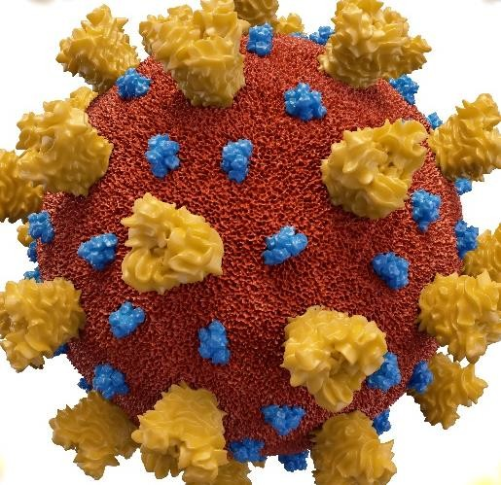

Example?
If your minimum income floor is set to
£1,000 per month and your earnings were
£600 for the month then your benefits would be based on earnings of £1,000, even though you earnt £400 less.
With the new temporary scheme, your credit award would be based on your actual earnings of £600 and so this would increase your universal credit claim.

Deferring Income Tax

Time to pay offer
Page 8

As a sole trader, you need to make a payment on account by the 31st July 2020. The payment on account will be 50% of your tax liability for the tax year 2018/19.
Example?
Your income tax liability for the tax year 2018/19 was £5,000.
Your first payment will have been due by 31st January 2020 for £7,500 (£5,000 + £2,500 (50%)).
Your second payment for the remainder of the 50% (£2,500) would be due for the 31st July 2020.
For those of you who need to make a payment on account for the 31st July 2020, your payment will be deferred until the 31st Jan 2021.

Will I be charged Interest on this deferral?
No penalties or interest for late payment will be charged in the deferral period.

How do I apply for this scheme?
The scheme is automatic, you do not have to apply for this scheme to HMRC
If you already have an outstanding tax liability with HMRC and you have or may miss your next tax payment due to COVID-19, then please call HMRC on 0800 0159 559.
These arrangements are agreed on a case by case basis and are tailored to individual circumstances and liabilities.

.

Individuals & Employees

Job Retention Scheme
HMRC will be supporting your employer by paying 80% of your wages (maximum of £2,500 per month) and so the cost to your employer will only be 20% of your total wage. You will be eligible for this if you are categorised as a ‘furloughed employee’ by your employer.
Our understanding is that your employer must not have laid you of work in order to apply for this scheme.
The scheme is currently available for 3 months starting from 1st April 2020.
However, your employer may back date the claim from the 1st March 2020.

What if I earn more than £2,500?
Unfortunately, the reimbursement will be capped at £2,500.
Example?
So, if your total wages is £3,000 per month, HMRC will only contribute
£2,500 and your employer will expected to cover the remainder £500.

Page 9

What if I am on a Zero-hour contract?
The chancellor mentioned in his speech that the scheme would cover all individuals under the PAYE scheme.
Therefore, we would expect employees on Zero-hour contracts to also be protected by the new scheme.
It has been suggested that your February Income will be used to determine your gross wage.
.
What if I am an agency worker?
We expect the same rules under zero hour contract to also apply to agency workers.
However, we will wait for further clarification from HMRC.

Statutory Sick Pay
Statutory sick pay is currently £94.25 per week. Statutory sick pay is normally available from the 4th day of your illness.
However from the 13th March 2020, if you have been of sick or have had to self isolate due to Covid-19 then you will be entitled to SSP from day one.

Do I need to provide a GP fit note for this scheme?
There is no requirement for you to provide a GP fit note however if your employer requires one then you have been advised to obtain one from the NHS 111 online.

Universal & Working Tax Credit
If you work a certain number of hours and have an income below a certain level, you could get up to £1,960 a year in working tax credit. This is known as the basic element.

How has the scheme been changed?
For those on working tax credit, your basic element will be increased by
£1,000 for the next 12 months, making the basic element £2,960.
The standard universal credit allowance will also increase by £1,000 for the next 12 months. How much you get depends on your earnings and other factors.
Page 10

Mortgage Payment Holiday
Your mortgage payment may be one of your highest expenses.
On the 17th March 2020 it was announced that homeowners including landlords of buy to let mortgages affected by COVID-19 can apply for a mortgage payment holiday of up to 3 months.

Will this affect my credit score?
Many banks will have different approaches, speak to your bank to discuss your concerns.

What about interest payments on the help to buy scheme?
On the 18th March 2020,the government confirmed it would offer interest free payment holidays to borrowers struggling to pay back their help to buy loans.

How do I apply for this scheme?
Please get in touch with your bank for more details, alternatively you may be able to apply online to speed up the process.
Please note that some lenders may recalculate your monthly mortgage payments after 3 months and this may result in higher capital & interest payments.

Other Loans
Many lenders are now revising their terms and conditions on your loans and credit cards.
Get in touch with your lender to see how they can help you.
Page 11

Get in touch with your lender to see how they can help you.
Statement
This document has been compiled by the Khoja Shia Ithna Asheri Muslim Community of Birmingham to understand the help available to you from the government.
It is understandable that this is a very stressful and upsetting time and we would like to help in any way we can.
If you would like further assistance, please do not hesitate to contact us via the Idaara COVID-19 helpline 07542 448863
Best of luck, stay safe and please remember all members in your duas.

COVID-19 Economic Task Force, KSIMC Birmingham

This information has been compiled and donated to KSIMC Birmingham by Brother Shabbar Jaffer.

General Disclaimer: This document is intended to provide general information only. The article is not intended as, and should not be taken as, financial, tax, legal, consulting, or any other type of advice.

